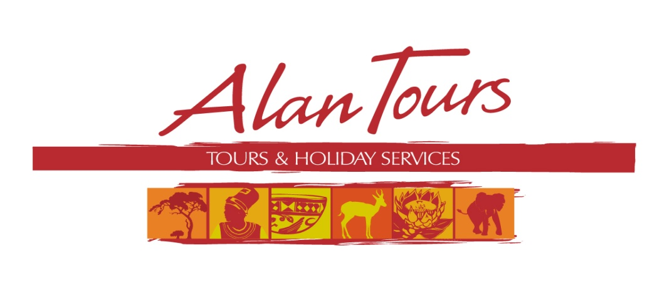

Alan Fogarty, Tours and Holiday Services c.c.

Close Corporation no. 2005/15064

Cell: +27 (0) 72 358 4634

Tel: +27 (0) 41 378 1486

Fax: +27 (0) 86 603 3701

[info@alantours.co.za](mailto:info@alantours.co.za)

[www.alantours.co.za](http://www.alantours.co.za/)

**Full Day tours 2014-2015**

**Valid 1 November 2014 - 31 October 2015**

Single travellers welcome (30% single supplement)

Group rates available on request

http://www.alantours.co.za/images/gallerybanner.jpg

|  |  |  |  |
| --- | --- | --- | --- |
| **Tour** | Code | **Full Day Tours** | ZAR pp |
| Full Day Tour | FD06 | **The Original BIG 7 Safari –**  **Algoa Bay and Addo Elephant National Park**  Start the morning on the protected waters of Port Elizabeth’s Algoa Bay searching for Dolphins, Seals, Sharks and the seasonal Humpback and Southern Right Whales. Circumnavigate St Croix Island for close up views of the largest breeding colony of African Penguin in the world. Return for light lunch in the harbour before departing to the Addo Elephant National Park for an exciting and informative game drive, scanning the thickets for the more traditional members of the BIG 5 and other animals, birds and reptiles.  **Departure: 08.00**  **Duration: +- 10 hrs**  **Included: transfers, boat tour, entrance/conservation fee, light lunch, fresh coffee, bottled water** | 2 750.00 pp |
| Full Day Tour | FD01 | **Addo Elephant National Park**  **Exciting and informative game drives through Addo Elephant National Park, one of the most popular National Parks in South Africa. The reserve is home of more than 600 Elephants, Lions, Buffalo, Zebra, Eland and Antelope amongst the many other species of animals and bird life.**  **Departure: 7:30**  **Duration: +-10 hrs**  **Included: transfers, entrance/conservation fee, light lunch, fresh coffee, bottled water**  **Optional extra: sunset/night game drive in open parks vehicle** | 1 650.00 pp |
| Full Day Tour | FD03 | **Addo Elephant National Park and Elephant Back Safari**  **Visit one of the most popular National Park South Africa’s, home of more than 600 Elephants, Lions, Buffalo, Zebra, Eland and Antelope amongst the many other species of animals and bird life. In the Zuurberg Mountain we have a memorable experience of riding these magnificent giants in the valley thickets. There is a chance to interact while you feed the bulls, after which they get a chance to swim and mud bathe at the waterhole.**  **Departure: 7:30**  **Duration: +-10 hrs**  **Included: transfers, entrance/conservation fee, elephant back ride, light lunch, fresh coffee, bottled water**  **Note: it is essential to wear long pants or jeans** | 2 500.00 pp |
| Full Day  4 x 4Tour | FD05 | **4 x 4 Tour Kabouga Section – An amazing diversity**  **Spend a day exploring this rough terrain in the northern Addo Elephant National Park; keep an eye out for Eland, Red Hartebeest, Zebra, Klipspringer and Warthog amongst the many other species of animals and birds (no Lions or Elephants in this area). Stop for a well-prepared picnic lunch on the banks of the river and at scenic viewpoints between slopes through which we need to negotiate the Land rover. Learn the fascinating history of a running battle between the British and Boers through these rugged valleys and mountain peaks.**  **Departure: 7:30**  **Duration: +- 10 hrs**  **Included: transfers, entrance/conservation fee, picnic lunch, fresh coffee, bottled water** | 2 500.00 pp |
| Full Day Tour | FD09 | **Country Roads – Western District**  **Wild flower reserve, wooded valleys and modern bridges combine to start a journey through this picturesque western part of the Eastern Cape. Characterized by the uninhabited, endless golden beaches of the Indian Ocean and bordered by the mountains in the north there are Nature Reserves and the Baviaanskloof, a World Heritage Site, well laid out, productive farmlands, citrus orchards. Discover the largest sundial in Africa and the last resting place of the Khoikhoi woman Sarah Baartman.**  **Departure: 8:00**  **Duration: +- 8hrs**  **Included: transfers, entrance/conservation fee, fresh coffee, light lunch, bottled water** | 1 750.00 pp |
| Full Day Tour | FD07 | **The Garden Route from Port Elizabeth to The Crags**  **Depart via the coastline to a Wild Flower reserve and Storms River Bridge for breakfast. Enjoy the stunning scenery of Jeffreys Bay, the temperate Tsitsikamma National Park on the famous Garden Route. Visit Monkeyland and Birds of Eden with the largest enclosed free flight dome in the world.**  **Departure: 8:00**  **Duration: +- 10 hrs**  **Included: transfers, entrance/conservation fees, breakfast, light lunch, bottled water** | adult  2 300.00 pp  children 1 950.00 pp |
| Full Day Tour | FD04 | **Addo Elephant National Park and Sunset River Cruise**  **Exciting and informative game drive through one of the most popular National Park South Africa’s, home of more than 500 Elephants, Lions, Buffalo, Zebra, Eland and Antelope amongst the many other species of animals and bird life. The reserve is home of more than 600 Elephants, Lions, Buffalo, Zebra, Eland and Antelope amongst the many other species of animals and bird life. Before the shadows merged into dusk we slowly cruise on the Sundays River watching for birds and game along the way.**  **Departure: 7:30**  **Duration: 10 hrs**  **Included: transfers, entrance/conservation fees, fresh coffee, light lunch, sunset cruise, bottled water** | 1 950.00 pp |
| Full Day Tour | FD10 | **Fun and Adventure: Surges of adrenalin along the famous Garden Route**  **During a Canopy tour you glide through the forest canopy attached to zip lines. While, as an optional extra, the ultimate thrill belongs to hurling yourself off the 216 m high Bloukrans Bridge Bungy jump, the highest in the world. Visit Monkeyland and Birds of Eden with the largest enclosed free flight dome in the world.**  **Departure: 7:30**  **Duration: +-10 hrs**  **Included: transfers, entrance/conservation fees, Canopy tour, light lunch, fresh coffee, bottled water**  **Excluded: Bungy jump**  **Canopy tour not suitable for children under 7 years** | adult  2 450.00 pp  Children  2 250.00 pp |
| Full Day Tour | FD12 | **Bird watching in and around Port Elizabeth**  **A guided tour of SAMREC, the marine re-habilitation centre and the operational lighthouse at Cape Recife. Search the shoreline for the many species of Waders, Shore and Marine birds that utilize this important area, the endangered Black oystercatcher and Rosette tern amongst the many different species.**  **We departing inland to the Island reserve and discover the hidden secrets of the Eastern Cape subtropical thickets.**  **Departure: 7:30**  **Duration: +- 8 hrs**  **Included: transfers, entrance/conservation fees, fresh coffee, light lunch, bottled water** | 1 250.00 pp |
| Full Day Tour | FD08 | **Historical Tour of the Eastern Cape’s Albany District**  **Echos of the past, an informative excursion into the culturally vibrant Eastern Cape district. Visit old fortified farmhouses, monuments, stone churches in Bathurst and Port Alfred. The Clay Fort, once the scene of the start of a war. Visit Fraser’s Signal Tower, a tiny field Hospital and many other places on the way to Grahamstown.**  **Departure: 08.30.**  **Duration: +- 10 hrs.**  **Included: transfers, entrance fees, fresh coffee, light lunch, bottled water** | 2 150.00 pp |
| Full Day Tour | FD11 | **Addo Elephant National Park and Tooth and Claw Tour**  **Exciting and informative game drives through the ever-popular Addo Elephant National Park, home to over 600 African Elephants. In the afternoon a game drive through a nearby private game reserve, searching for Lion, Giraffe and Hippo amongst many others in this park. Buffet dinner in open Boma.**  **Departure 7:30**  **Duration: +-12 hrs**  **Included: transfers, entrance/conservation fees, fresh coffee, light lunch, evening meal, bottled water** | 2 150.00 pp |
| Full Day Tour | FD02 | **Arts & Antiques Tour Port Elizabeth**  **We visit the Central suburbs of Port Elizabeth with the many galleries, the Nelson Mandela Metropolitan Art Museum, Art and Antique shops, studios and sidewalk displays. In New Brighton we visit artists and the Red Location Museum, a poignant memorial to the struggle for democracy.**  **Departure: 9:00**  **Duration: +- 7 hrs**  **Included: entrance fees, light lunch, bottled water** | 1 100.00 |
| Full Day Tour | FD16 | **Elephant Back Safari**  **A memorable experience riding these magnificent Giants deep in the valley thickets. Interact with your newfound friends while feeding the Elephant bulls, after which they get a chance to swim and mud bathe at the waterhole.**  **Departure: 8:00**  **Duration including transfers: +- 8 hrs**  **Included: transfers, elephant back ride, bottled water**  **Note: it is essential to wear long pants or jeans.** | 2 100.00 pp |
| Full Day Tour  Seasonal | FD14 | **The Eastern Cape Wild Aloe Tour**  **This is a winter tour as it is only at this time of the year, June through to August, that the wide spread and spectacular display of wild Aloes takes place. A time of the year when most plants are hibernating, either having lost their leaves and flowers to await the new spring in their dull winter overcoats or await shrouded in a coat of autumn browns and oranges for the new sap to produce the abundant new growth of spring.**  **Departure: 8:30**  **Duration including transfers: +- 9.5 - 10 hrs**  **Included: light lunch, bottled water** | 1 950.00 pp |

http://www.alantours.co.za/images/gallerybanner.jpg

Wamkelekile eAfrica

Welcome to Africa